PROJECT FINAL REPORT ON WP5 DISSEMINATION AND EXPLOITATION

Project Acronym: | BUGI
Project Full Title: | Western Balkans Urban Agriculture Initiative
Project No.: | 586304-EPP-1-2017-BA-EPPKA2-CBHE-JP
Funding Scheme | Erasmus Plus
Coordinator: | University of Sarajevo
Project Start Date: | October 15, 2017
Project Duration: | 48 months

Table of Contents
1 Introduction 5
1.1 Related assumptions and risks 6
1.2 Tasks 7
2 Methodology 7
3 Results 10
4 Conclusions 19
5 References 20

Tables

Table 1: WP 5 Deliverables/results/outcomes 7
Table 2: Framework for targeting the system change by implementing the task in WP5. 8
Table 3: Framework for monitoring dissemination and exploitation activities. 8
Table 4: Template for r monitoring scientific publications. 9
Table 5: Presentation activities BUGI WP5. 11
Table 6: Journal activities BUGI WP5. 14
Table 7: Media activities BUGI WP5. 15

Figures
Figure 1: Response to question “What are the highlights of BUGI project for you” provided by BUGI partners at the Activity 3.4. Workshop on Distance Learning of the Erasmus+ project Western Balkans Urban Agriculture Initiative – BUGI (586304-EPP-1-2017-BA-EPPKA2-CBHE-JP) in Donja Gorica, September 6th, 2019. 6
Figure 2: WP5 contributed to promoting urban agriculture at different scales. 10
Figure 3: Green entrepreneurship portal web-page. 17
Figure 4: Green entrepreneurship portal: Example for BiH. 18
Figure 5: Green entrepreneurship portal: Example for Montenegro. 18
Figure 6: Green entrepreneurship portal: Example for Kosovo. 19

DOCUMENT CONTROL SHEET

Title of Document: | BUGI
Work Package: | WP 5 Dissemination and exploitation
Last Version Date: | 04/10/2021
Status: | Final
Document Version: | v.03
File Name: | Dissemination strategy
Number of Pages: | 20
Dissemination Level: | Internal

VERSIONING AND CONTRIBUTION HISTORY

Version | Date | Revision Description | Partner responsible
v.01 | 10/09/2021 | First draft version | Rozalija Cvejić (BF UL)
v.02 | 24/09/2022 | Second draft version | Rozalija Cvejić (BF UL), University Mostar
v.03 | 04/10/2021 | Final version | Rozalija Cvejić (BF UL)

Introduction
Western Balkans Urban Agriculture Initiatives-BUGI (586304-EPP-1-2017-1-BA-EPPKA2-CBHE-JP) is an ERASMUS+ Capacity Building project in the field of Higher Education, funded by the European Commission in 2017. The BUGI project is composed of 8 partners representing 3 EU member states (Slovenia, Italy and Germany) and 3 Western Balkans states (Bosnia and Herzegovina, Montenegro and Kosovo). WP5 aimed at dissemination and exploitation activities that ensured visibility of the project activities, outcomes, achievements, and regular information dissemination for specific and general public, enhancing communication with target groups. This is a final report for WP5: dissemination and exploitation.
To achieve the aim WP5 focused developing Dissemination Strategy. WP team developed, promoted and administrated project visual identity: logo, Website with on-line database, Distance learning platform, Green Entrepreneurship E portal and android application, project social medias pages.
The dissemination of project results was done by utilizing all available Internet communication channels: project websites, project social media pages and networks. WP program country coordinator was involve in monitoring and evaluating the Green Entrepreneurship tools from different perspectives (economical, social, etc) while partner HEI co lead organization was responsible for developing and maintaining promotional material, website, and other project products in partner country languages.
WP team will established strategies and methodologies which ensured ongoing contacts with specific public-potential beneficiaries and stakeholders: SMEs, farmers unions, Start-ups organizations, NGOs, HEIs and academic staff, similar UA projects and professionals (at the international level).
WP team designed campaigns for general public which will educate and raise awareness about UA principles and benefits but in the same time reach out to potential beneficiaries. To reach students, public campaigns were organized in partners HEIs campus. At the end of the project open door event at partner HEIs was implemented to present project outcomes. To reach urban population social medias, printed posters, flyers, open door events were used.
Public decision makers were invited to open door event. City-adjusted farm strategies were be presented to local authorities. By the well established contacts with governance bodies partner HEIs presented project outcomes. UA international conference was organized to reach important international UA stakeholders. During this event project outcomes were be presented. New networks and future collaborations were at the hart important outcomes of this conference.
Project delivered papers to relevant international conferences or scientific journals on project implementation and achieved results.
Curriculum and LLL programs, based on analysis of current and future needs, will significantly contribute to the project sustainability and exploitations and students/trainees employability. The institutional recognition, curriculum accreditation, continuity of delivery of training courses to businesses and farmers, publications and learning infrastructure provided by the project, will ensure that the project sustainability and project outcomes exploitation is distributed beyond the lifetime of the project.
Some of the values, beliefs and outcomes of urban agriculture that WP5 partners wanted to bring across to different levels of society are presented in Figure 1.

Figure 1: Response to question “What are the highlights of BUGI project for you” provided by BUGI partners at the Activity 3.4. Workshop on Distance Learning of the Erasmus+ project Western Balkans Urban Agriculture Initiative – BUGI (586304-EPP-1-2017-BA-EPPKA2-CBHE-JP) in Donja Gorica, September 6th, 2019.

Related assumptions and risks
At the beginning of WP 5 the following assumptions were identified that later provided the basis for running the activities under the WP5:
- Public has high interests for agriculture/gardening, ecology, architecture and urban living;
- Social medias (Facebook, Tweeter, etc) are part of everyday life for most of urban dwellers;
- SMEs and farmers are interested to improve their production:
- Risks:
- Slowness of staff to posts articles and news;
- Enterprises and farmers do not have time or don’t recognize their interests;
- The dissemination activities missed urban stakeholders;
- Inadequate project promotion messages;
- Inadequate level of project visibility due to partners’ lack of commitment to use project corporate signs and dissemination tools.

Tasks
The following task were planned under the WP5 (Table 1:):
- To create the dissemination plan (completed);
- To develop, promote and administrate project logo, websites and social medias pages (completed);
- To develop, promote and maintain ongoing communication at local, regional and international level with potential beneficiaries (completed);
- To create promotional material (completed);
- To organize and implement general and specific campaigns for promotion of project results (completed);
- To organize general UA and alternative marketing and sales channels (e.g. CSA, farmer markets, box schemes / delivery services, care farming, rent-a-field concepts, etc.) (completed).
- Plan, organize and implement events (info days, open door days and UA international conference) (completed).
Based on these task Deliverable, result sand outcomes of individual tasks are show in Table 1.
Table 1: WP 5 Deliverables/results/outcomes
No | Title | Type
5.1. | Dissemination Strategy | Report
5.2. | Project web site and social media channels | Service/product
5.3. | Green Entrepreneurship | Service/product
5.4. | Distance learning platform | Service/product
5.5. | Project promotional materials | Service/product
5.6. | Scientific contributions | Service/product
5.7. | Info days, open door day and UA conference | Event
5.8. | Interim and final report on dissemination and exploitation | Report

Methodology
To evaluate the WP5 dissemination and exploitation activities within the project. Following the Moore et al. (2015) system change framework, the following three main questions outlined by the final report are:
Scale Deep: How impactful was BUGI project in terms of reaching cultural roots through dissemination activities; and how did it change values and beliefs with respect to urban agriculture?
Scale Up: What are the main scientific findings of the BUGI project and what is their relevance for laws and policies aiming at developing urban agriculture at different levels (e.g. EU, regional, and local scale)?
Scale Out: What impact did the BUGI project reach in terms of replication and dissemination, and which target groups and communities did it influence the most?
Table 2 explains the predominant system change level goal by WP5 tasks with respect to urban agriculture through dissemination and exploitation of BUGI project results.
Table 2: Framework for targeting the system change by implementing the task in WP5.
WP5 tasks | System change level goal
1. To create the dissemination plan; |  |  | Scale out
2. To develop, promote and administrate project logo, websites and social medias pages; |  |  | Scale out
3. To develop, promote and maintain ongoing communication at local, regional and international level with potential beneficiaries; |  | Scale up
4. To create promotional material; |  |  | Scale out
5. To organize and implement general and specific campaigns for promotion of project results; |  |  | Scale out
6. To organize general UA and alternative marketing and sales channels (e.g. CSA, farmer markets, box schemes / delivery services, care farming, rent-a-field concepts, etc.). | Scale Deep |  | Scale out
7. Plan, organize and implement events (info days, open door days and UA international conference). |  | Scale up | Scale out
To follow the activities under specific task of WP a monitoring framework was established by the lead partner (UL) to follow the progress of project partners under WP5. An excel spreadsheet monitoring template for continuous following of the activities was updated by project partners regularly and serves as an input for the final WP5 report. The structure of the monitoring template is shown in Table 3 and Table 4.
Table 3: Framework for monitoring dissemination and exploitation activities.
Field | Details (to be filled by partner(s))
Partner(s) responsible
Title
Date of dissemination
Short description of work performed (2-3 sentences about the dissemination)
Type of dissemination action (1)
Target Audience (2)
Size of audience
Benefits for project (2-3 sentences)
Relevance to specific work in BUGI (WP, task,
overall objectives, etc)
Comments/feedback from target Audience
Table 4: Template for r monitoring scientific publications.
Title of the publication | Authors | Title of the periodical | Publisher | Place | Year | Relevant pages

Results
Figure 2 summarises WP activities. WP5 contributed to promoting urban agriculture at different scales with a least 13 event presentations, 4 journal activities and 7 media activities. Together this is 24 dissemination activities, on average that is 6 events per year, or one event every two months.
Figure 2: WP5 contributed to promoting urban agriculture at different scales.
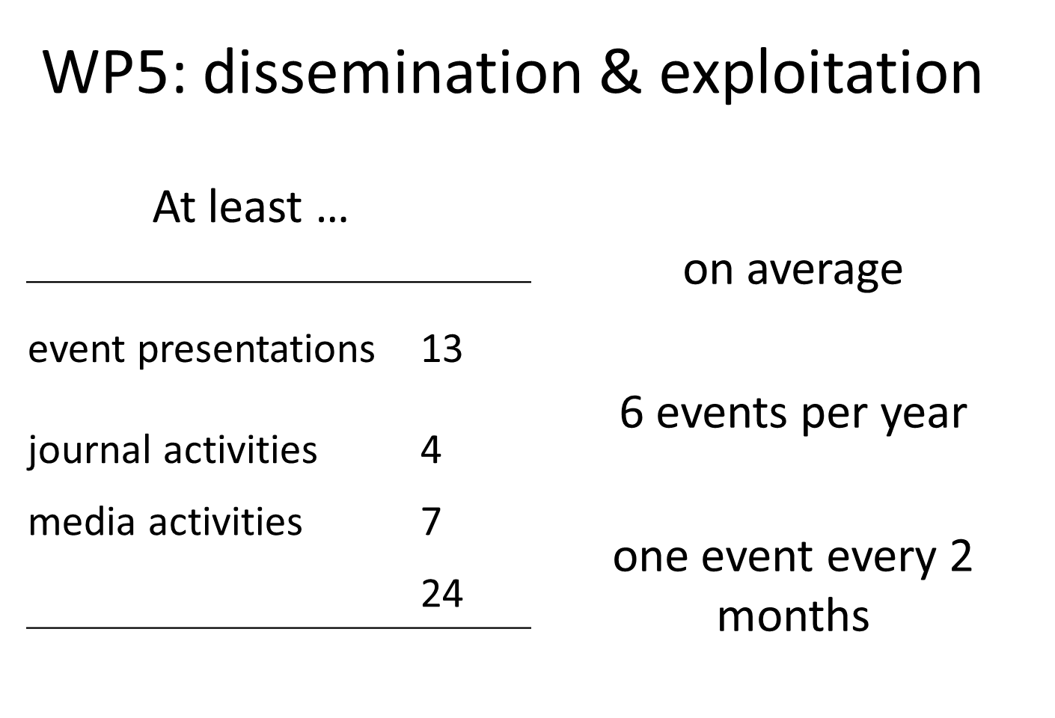

Table 5: Presentation activities BUGI WP5.
TYPE OF EVENT | NAME OF EVENT  (please add name of event during which presentation/session/workshop was held) | DATE(s) of event  (Format: DD.MM.YYYY) | PLACE | Main IMPLEMENTER (partner) | TYPE OF AUDIENCE | SIZE of audience (approx.) | PRESENTATION/WORKSHOP TITLE  (+ number of slides on BUGI or info on how the project was promoted in case no presentation given) | EVENT LEVEL (please insert: LOCAL or REGIONAL or NATIONAL or EUROPEAN or INTERNATIONAL level) | COUNTRIES ADDRESSED  (if applicable - please insert country names) | WEBLINK for event | Other evidence available | Remarks
Presentation of BUGI project | National Erasmus+ Information Day in BiH 2018 | 13.11.2018 | UNSA | Erasmus Office in B6H and UNSA | National Erasmus+ Information Day in BiH 2018 | over 145 | presentation 15 slides | National | BA | https://www.erasmusbih.com/bs/novosti/national-erasmus-information-day-in-bih-2018
Presentation of BUGI project | National Erasmus+ Information Day in BiH 2017 | 12.11.2017. | University Banja Luka | Erasmus Office in B6H and University Banja Luka | National Erasmus+ Information Day in BiH 2017 | over 100 | presentation 15 slides | National | BA | https://www.erasmusbih.com/index.php/news/193-national-erasmus-information-day-in-bih-2017
INFO DAY | INFO DAY of BUGI Project | 43462 | UNSA | PPF UNSAhttp://www.unsa.ba/en/doga%C4%91aji/bugi-project-presentation | INFO DAY | over 30 | presentation 15 slides | National | BA | http://www.unsa.ba/en/doga%C4%91aji/bugi-project-presentation | https://ppf.unsa.ba/clanak.php?ID=552
Meeting with Municioality Stari Grad Sarajevo | Meeting with Municioality Stari Grad Sarajevo | 21.12.2017. | MUNICIPALITY STARI GRAD, SARAJEVO |  | MEETING AT THE MUNICIPALITY STARI GRAD, SARAJEVO |  |  |  | BA
Sajam Interio 2019 | Sjama namještaja Interio 2019 | 13.-17.3.2019 |  |  |  |  |  |  | BA
Meeting with Municipality Novo Sarajevo, Sarajevo | UNSA | 13.12.2017. | Skenderija, SARAJEVO |  | Participants | over 1000 | Presentation of project and students achivement | international level | BA
Presentation of BUGI consumer preferences survey at Conference | 30th INTERNATIONAL SCIENTIFIC-EXPERT CONFERENCE OF AGRICULTURE AND FOOD INDUSTRY  Sarajevo, September 26 – 27, 2019 | 26/27.09.2019 | Sarajevo, BiH | UNSA | Conference participants (Scientists, Students) | 25 | 14 slides / Presentation in Agricultural economcis session | international level | international, especially Western Balkan countries, but also beyond (Italy, …) | https://ppf.unsa.ba/uploads/Agri/FINALNA%20AGENDA%20KONFERENCIJA%202019%2023_09_2019.pdf
Open Door of BUGI Project | Open Door of BUGI Project | 44342 | Sarajevo, BiH | UNSA | Project partners, students and companies | over 30 | Presentation 15 slides | international level | BA | https://www.bugi.unsa.ba/open-door-of-erasmus-project-western-balkans-urban-agriculture-initiative-bugi/
Presentation of GREEN ENTREPRENEURSHIP E PORTAL AND ANDROID APPLICATION | Presentation of GREEN ENTREPRENEURSHIP E PORTAL AND ANDROID APPLICATION | 27.05.2021. | Sarajevo, BA | UNSA | Project partners, students and companies | 25 | Presentation 28 sldes | International level | BA | https://www.bugi.unsa.ba/online-promotion-and-training-presentation-of-green-entrepreneurship-e-portal-and-android-application/
Presentation of BUGI consumer preferences survey at Conference | 30th INTERNATIONAL SCIENTIFIC-EXPERT CONFERENCE OF AGRICULTURE AND FOOD INDUSTRY  Sarajevo, September 26 – 27, 2019 | 26/27.09.2019 | Sarajevo, BiH | SWUAS | Conference participants (Scientists, Students) | 25 | 14 slides / Presentation in Agricultural economcis session | international level | international, especially Western Balkan countries, but also beyond (Italy, …) | https://ppf.unsa.ba/uploads/Agri/FINALNA%20AGENDA%20KONFERENCIJA%202019%2023_09_2019.pdf
Visit of Chinese Delegation (Agricultural and Rural Development Ministry of China) at SWUAS, Department of Agriculture, Soest; Presentation of running international projects including BUGI |  | 43444 | UNSA | UNSA | PPF UNSA and EGE UNIVERSITY | 28 | Research activities of the UNSA (slides connected to BUGI: 10 slides) | international level
INFO DAYS | UDG Open doors | 23/04/2018 | University Donja Gorica | UDG Montenegro | High scool seniors, students | 150 | 12 slides presentatuon | National
Science festival | Dani nauke | 9-12/10/2018 | Capital plaza Podgorica | UDG Montenegro | Students, general public | 300 | 14 slides presentation | National |  | http://daninauke.me/category/festival-2018/
 | Cluster Meeting of CBHE projects focusing on the Curriculum Development | 29/11/2018 | University Montenegro | UDG Montenegro | HEI personnel | 25 | 10 slides presentation | National
Presentation of BUGI consumer preferences survey at Conference | 30th INTERNATIONAL SCIENTIFIC-EXPERT CONFERENCE OF AGRICULTURE AND FOOD INDUSTRY  Sarajevo, September 26 – 27, 2019 | 26/27.09.2019 | Sarajevo, BiH | SWUAS | Conference participants (Scientists, Students) | 25 | 14 slides / Presentation in Agricultural economcis session | international level | international, especially Western Balkan countries, but also beyond (Italy, …) | https://agriconference.ppf.unsa.ba/

Table 6: Journal activities BUGI WP5.
Main PUBLISHER (partner) | DATE of publication | JOURNAL TITLE | JOURNAL LEVEL (please insert: NATIONAL or EUROPEAN or INTERNATIONAL level) | COUNTRIES ADDRESSED | ARTICLE TITLE | Article AUTHOR(s) | No. of copies issued | No. of people reached (approx.) | WEBLINK of article | Evidence available | Comments
 | (Format: YYYY.MM.DD) |  |  | (if applicable - please insert country names)
Alma Mater Studiorum University of Bologna | 2019 | Urban Farm2019-Book Finale Challenge | international | Italy | Western Balkans Urban Agriculture Initiative-BUGI
University Sarajevo | 2019 | Radovi poljoprivredno-prehrambenog fakulteta univerziteta u Sarajevu |  | Bosnia nad Herzegovina | ENTREPRENEURIAL EDUCATION SKILLS IN URBAN AGRICULTURE OF BOSNIA AND HERZEGOVINA | Alen Mujčinović, Sabrija Čadro, Mirza Uzunović, Merima Makaš, Petar Glamočlija, Pakeza Drkenda |  |  | https://www.researchgate.net/publication/338775850_ENTREPRENEURIAL_EDUCATION_SKILLS_IN_URBAN_AGRICULTURE_OF_BOSNIA_AND_HERZEGOVINA
Alma Mater Studiorum University of Bologna | 2020 | Acta Hortic. 1279. ISHS 2020. DOI 10.17660/ActaHortic.2020.1279.7 |  |  | Promoting education and training in urban agriculture building on international projects at the Research Centre on Urban Environment for Agriculture and Biodiversity | G. Pennisia, F. Magrefi, N. Michelon, G. Bazzocchi, L. Maia, F. Orsini, E. Sanyé-Mengual and G. Gianquinto |  |  | https://www.actahort.org/books/1279/1279_7.htm
 |  | XXX IHC – Proc. VII International Conference on Landscape and Urban Horticulture

Table 7: Media activities BUGI WP5.
TITLE OF MEDIUM  (e.g. name of the newspaper/magazine, name of the website, name of TV network etc.) | Main IMPLEMENTER (partner) | DATE of publication  (Format: YYYY.MM.DD) | PLACE  (if applicable) | TITLE OF PUBLICATION/ ACTIVITY | EVENT LEVEL (please insert: LOCAL or REGIONAL or NATIONAL or EUROPEAN or INTERNATIONAL level) | Countries addressed  (if applicable - please insert country names) | No. of copies issued | No. of people reached (approx.) | WEBLINK | Evidence available | Comments
Televizija Kantona Sarajevo | UNSA | 09.11.2018. | Televizija Kantona Sarajevo | Introduction and presentation of BUGI project |  | Bosnia and Herzegovina |  |  | https://we.tl/t-gECTGdZ2qq
www.unmo.ba www.af.unmo.ba Oslobođenje Bljesak info Pogled.ba | UNMO | 5th of February 2019 | Agromnediterranean faculty Dzemal Bijedić University of Mostar | Presentation of University international and scientific-reserach projects as part of the activites of "42 godišnjica Univerziteta "Džemal Bijedić"u Mostaru" | NATIONAL | Bosnia and Herzegovina |  | 39 attended the presentation | https://www.oslobodjenje.ba/vijesti/bih/zapocelo-obiljezavanje-42-godisnjice-univerziteta-dzemal-bijedic-431112? https://www.bljesak.info/sci-tech/obrazovanje/predstavljeno-18-znanstveno-istrazivackih-i-medunarodnih-projekata-na-unimo/261690 https://www.facebook.com/af.unmo.ba/photos/pcb.1436839423119547/1436839326452890/?type=3&theater | Attendence sheet
Darovi prirode | UNSA | 29.12.2019. | Televizija Kantona Sarajevo | Youtube video | national | Bosnia and Herzegovina |  |  | https://www.youtube.com/watch?v=97g8t84ardA
Impuls znanja | UNSA | 11.03.2019. | AMT Studio, TV Vogošća, | Youtube video | national | Bosnia and Herzegovina |  |  | https://www.youtube.com/watch?v=c34r3sgfUU8
Sarajevska špica | UNSA | 44342 | Televizija Kantona Sarajevo | Youtube video | national | Bosnia and Herzegovina |  |  | https://www.youtube.com/watch?v=GIUrViI37iU
Website South-Westphalia University of Applied Sciences www.fh-swf.de | SWUAS | in 2018 | https://www4.fh-swf.de/de/home/ueber_uns/standorte/so/fb_aw/forschungundprojekte_1/aktuelleforschungsprojekte/kompetenzschwerpunkt___landwirtschaft_in_ballungsraeumen__/bugi/Index.php | Web text providing basic information on BUGI project for German speaking people | due to German language it should be considered to be on national level | BUGI partner countries |  |  | https://www4.fh-swf.de/de/home/ueber_uns/standorte/so/fb_aw/forschungundprojekte_1/aktuelleforschungsprojekte/kompetenzschwerpunkt___landwirtschaft_in_ballungsraeumen__/bugi/Index.php
udg.edu.me | UDG Montenegro |  |  | news | international

Although the green entrepreneurship portal (reachable at https://greenentrepreneurship.bugi.unsa.ba/) has been running for only about half a year it is already evident that its expanding on its capacity and its relevance in the Western Balkans region. The web page and application provides entrance to local urban agriculture product in three countries, Bosnia and Hercegovina, Montenegro and Kosovo.
The level and type of portal development is different in all three countries. The portal for BiH focuses large number of food and cosmetic products (over 100) and fertilisation and growing equipment for urban farming. The focus is really on easy access to local products (select, buy, get delivered) (Figure 4). The portal for Montenegro offers products presented as an offer with emphasis on easy access and produced (get to know producer) (Figure 5). Whereas the portal for Kosovo is only at its initial stage, offering only representation of possible suppliers without a real option for an easy access to buying the goods (Figure 6).
Although it is too early for a full evaluation of direct socio-economic and environmental impacts that the green entrepreneurship portal has, its thriving use and its numerous products that are offered to support local supply of goods and services indicates the socio-economic and possibly favourable environmental impact is increasing.
Figure 3: Green entrepreneurship portal web-page.
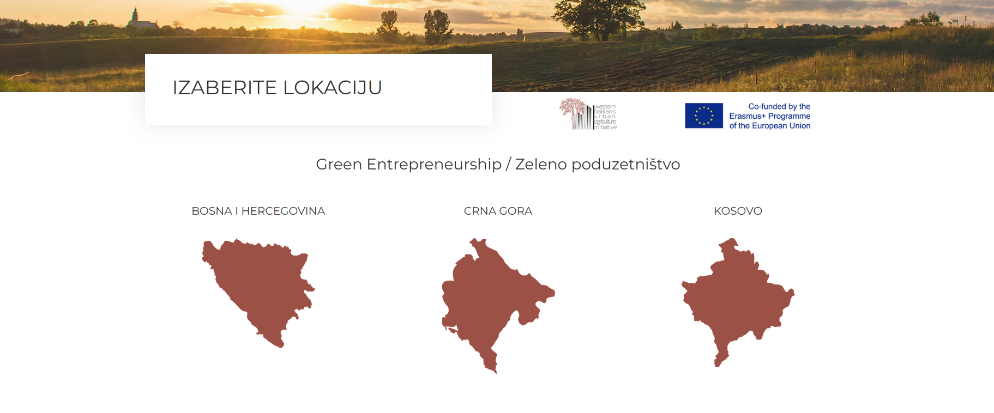

Figure 4: Green entrepreneurship portal: Example for BiH.
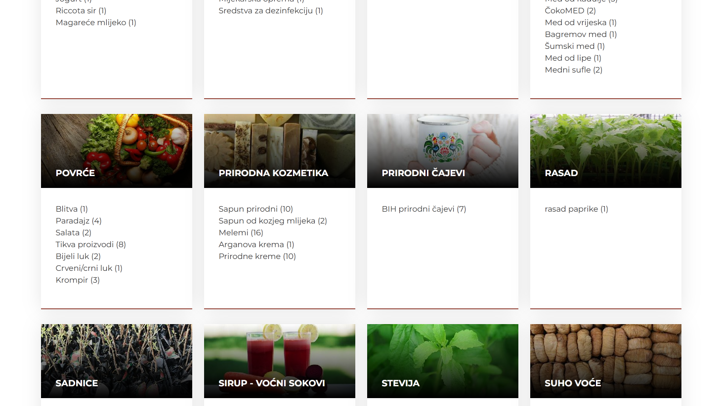
Figure 5: Green entrepreneurship portal: Example for Montenegro.
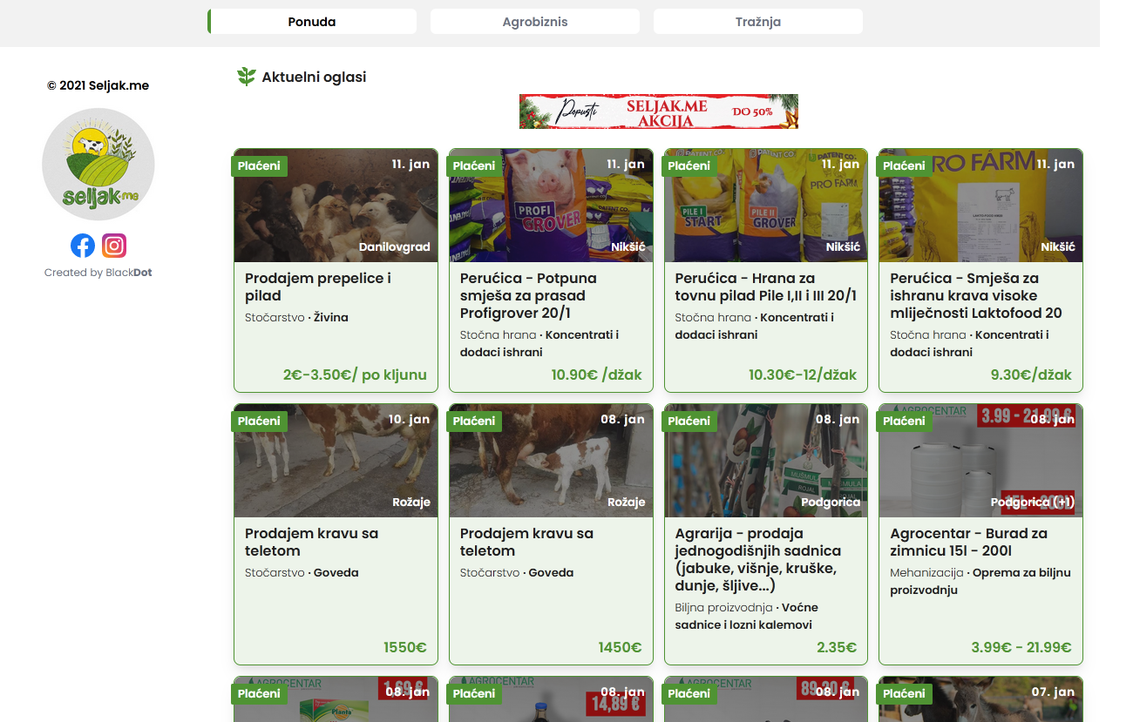

Figure 6: Green entrepreneurship portal: example for Kosovo.
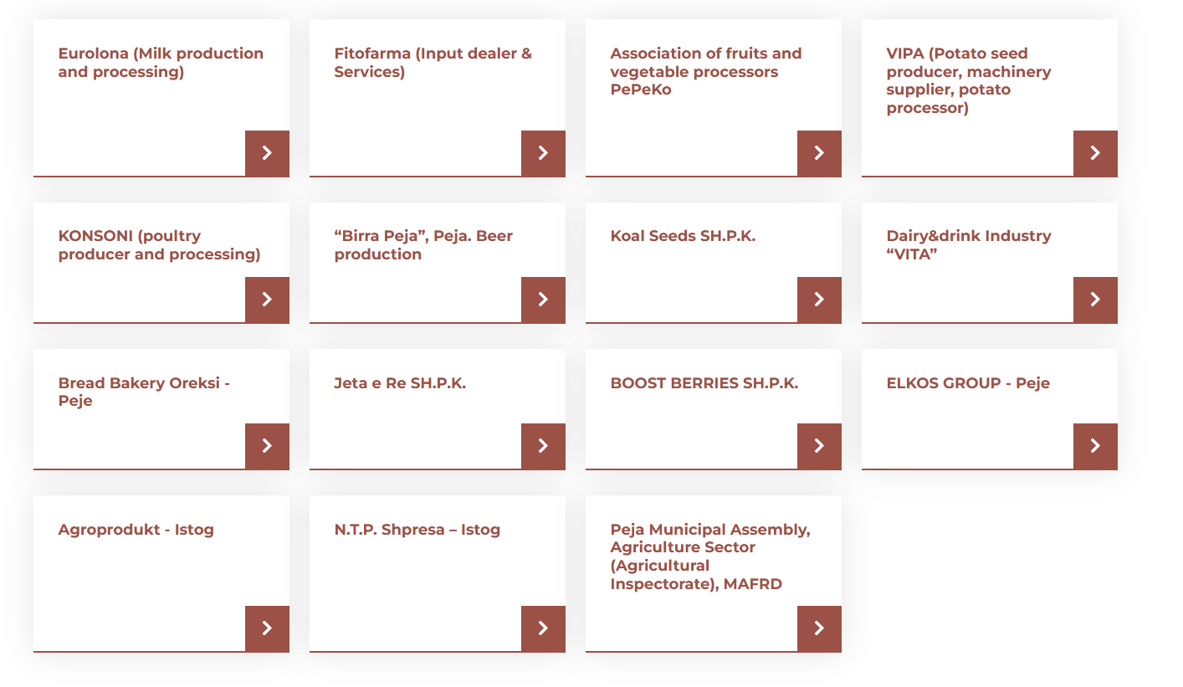

Conclusions
The WP5 has followed its strategy and fully provided the panned tasks and deliverables. Dissemination that supports BUGI outputs and results and the exploitation of results was ensured through project web site and social media channels, green entrepreneurship, distance learning platform, project promotional materials, scientific contributions, info days, open door day and final conference.
Dissemination to help reach high project impact in terms of reaching cultural roots (i.e. changing habits to buying local) was most intensely targeted and partially already achieved by organising an alternative marketing and sales channels (e.g. CSA, farmer markets, box schemes / delivery services, care farming, rent-a-field concepts, etc.) through green entrepreneurship portal.
To scale-up the project outcomes and results related to advancing approaches for bringing together more efficiency education, research and business in the context of urban agriculture, several scientific publication have been published by the project partners. These provide the basis for further development of laws and policies aiming at developing urban agriculture at different levels (e.g. EU, regional, and local scale), that was supported by strong promotion and ongoing communication at local, regional and international level with potential beneficiaries (consumers, suppliers).
Scaling out for promoting replication and dissemination was efficiently established by administrate project logo and project website, social media channels, promotional materials, campaigns for promotion of project results, organised alternative marketing and sales channels, info days, open door days and international conference. Stakeholders targeted by these activities were general public, public decision making bodies, national and international organizations, entrepreneurial sector (SMEs, farmers unions, farmers, start-up companies, etc.), local public decision making bodies (departments for urban planning, agriculture, ecology, etc.), actors outside consortium and faculties (agriculture, economics, applied science, social science, architecture, etc.) and students.

References
Moore M.L., Ridell D., Vocisano D., 2015. Scaling Out, Scaling Deep, Scaling Up, Scaling Deep. Strategies of Non-profits in Advancing Systemic Innovation. The Joiurnal of Corporate Citizenship, 58
BUGI Description of work, 2018: 37 p.

