Dissemination strategy

Project Acronym: | BUGI
Project Full Title: | Western Balkans Urban Agriculture Initiative
Project No.: | 586304-EPP-1-2017-BA-EPPKA2-CBHE-JP
Funding Scheme | Erasmus Plus
Coordinator: | University of Sarajevo
Project Start Date: | October 15, 2017
Project Duration: | 36 months

Contents
Dissemination strategy 1
Executive summary 4
INTRODUCTION 5
Short background on the project 5
Project Consortium 5
Work packages 6
WP5 structure 7
Dissemination objectives 9
Dissemination strategy 9
Dissemination methodology 10
Dissemination action plan 11
Dissemination tools and channels 12
BUGI project brand 12
Publications 14
Events 14
Web Site and Social Networks 15
Green entrepreneurship and Distance learning platform 17
Electronic mail 17
Dissemination Activity Assessment and Reporting 17
Annex 1 22
Dissemination report template 22

DOCUMENT CONTROL SHEET

Title of Document: | BUGI
Work Package: | WP 5
Last Version Date: | 13/10/2021
Status: | Final
Document Version: | v.05
File Name: | Project web site and social media
Number of Pages:
Dissemination Level: | Internal

VERSIONING AND CONTRIBUTION HISTORY

Version | Date | Revision Description | Partner responsible
v.01 | 13/10/2021 | Final version | Pakeza Drkenda (UNSA)

Executive summary

This delivery outlines the dissemination plan to be adopted by the Erasmus+ Project BUGI as a guideline for organizing and implementing the dissemination activities as provided in the description of the project work package 5. Its objective is to underline the activities designed to raise the awareness of specific and general audience to the results and impact of the BUGI project as an EU funded project. The document covers the written and visual identity of the project, and offers an overview of the tools designed to develop sound dissemination activities. The Dissemination plan is elaborated in conformity with the BUGI project provisions and taking into consideration the Communication and Visibility Manual for European Union External Actions elaborated by the European Commission.

INTRODUCTION

Short background on the project

Western Balkans Urban Agriculture Initiatives-BUGI (586304-EPP-1-2017-1-BA-EPPKA2-CBHE-JP) is an ERASMUS+ Capacity Building project in the field of Higher Education, funded by the European Commission in 2017 and running until 14.10.2020. The project aims to develop new Urban Agriculture master study curriculum and Lifelong learning (LLL) program in 3 Western Balkans (WB) countries: Bosnia and Herzegovina, Montenegro and Kosovo.

The new curriculum will be competence-based and interdisciplinary and will be built taking into consideration national strategies as well as farmers and entrepreneurial sector needs; it will foster higher education institutions (HEIs) internationalization, provide learning flexibility and mobility and promote transfer of knowledge, skills and technologies among partner universities.

The overall aim of the project is to increase capacities, sustainability, visibility and attractiveness of Western Balkans HEIs diversifying employment opportunities and social inclusiveness. The project will thus contribute to students/trainees employability, develop new networks and contribute to development of alternative food supply chains for farmers and conduct campaigns targeting important stakeholders. Project outcomes will promote enhancement of urban sustainability and green economy development in WB countries also focusing on the entrepreneurial sector.

Project Consortium

The BUGI project is composed of 8 partners representing 3 EU member states (Slovenia, Italy and Germany) and 3 Western Balkans states (Bosnia and Herzegovina, Montenegro and Kosovo).

Table 1. BUGI consortium

WP5 structure

Dissemination and exploitation activities will ensure visibility of the project activities, outcomes, achievements, and regular information dissemination to specific and general public, enhancing communication with target groups. Project planned activities/tasks and their outcomes are presented in Table 2.

Table 2. WP5 Deliverables/results/outcomes
No | Title | Type | Due date
5.1. | Dissemination Strategy | Report | 15.02.2018
5.2. | Project web site and social media channels | Service/product | 14.10.2020
5.3. | Green Entrepreneurship | Service/product | 14.10.2020
5.4. | Distance learning platform | Service/product | 14.10.2020
5.5. | Project promotional materials | Service/product | 01.05.2018
5.6. | Scientific contributions | Service/product | First:  15.07.2018  Second:  15.07.2020
5.7. | Info days, open door day and UA conference | Event | Info days:  15.09.2018  01.07.2018  15.01.2020  open door:  01.07.2020  UA conference:  01.09.2020
5.8. | Interim and final report on dissemination and exploitation | Report | First:  15.04.2019  Second:  01.10.2020

Dissemination tools and channels

BUGI project brand
BUGI Project logo, style sheet and PowerPoint templates have been designed. BUGI project brand inventory can be found at BUGI Project web Site www.bugi.unsa.ba.
To download original, editable formats partners could go to http://bugi.unsa.ba/sdm_downloads/bugi-project-brand/, or at the BUGI Project web Site in PMP menu. For password were responsable contact Co-leader at UNSA.
To download print ready flyers, posters, brochures, etc. please go to http://bugi.unsa.ba/mdocuments-library/?mdocs-cat=mdocs-cat-45&mdocs-att=Documents, or at the BUGI Project web Site in Documents menu, WP5, 5.5. Project promotional materials.

Web Site and Social Networks
The Social Networks and partners web sites/pages shall be used to disseminate BUGI project results and to increase the number of the targeted audience.
Web site to explain the project aims and objectives and to disseminate information about project activities and results has been designed and is available at: www.bugi.unsa.ba. As a dissemination channel, the Web site advertise products created by the project, journal articles, publications, and presentations at conferences.
- Green Entrepreneurship e-portal and application was developed: https://greenentrepreneurship.bugi.unsa.ba/#

Green Entrepreneurship e-portal and application menu, promote green economy and short food supply chains at local and regional level. BUGI Project web site included the link to e-portal. Green entrepreneurship e-portal and application will work as virtual association of UA farmers as well as other farmers in region. Green entrepreneurship e-portal has been linked to the official project web site as well as partners HEIs web sites.
Distance learning as an open-source learning platform will be linked to the official project web site as well as partners HEIs web sites. All partner HEIs will use the same platform. Additionally project proposed/developed teaching materials (books, scripts, tutorials) published as open educational resources (OER) will be placed on platform.

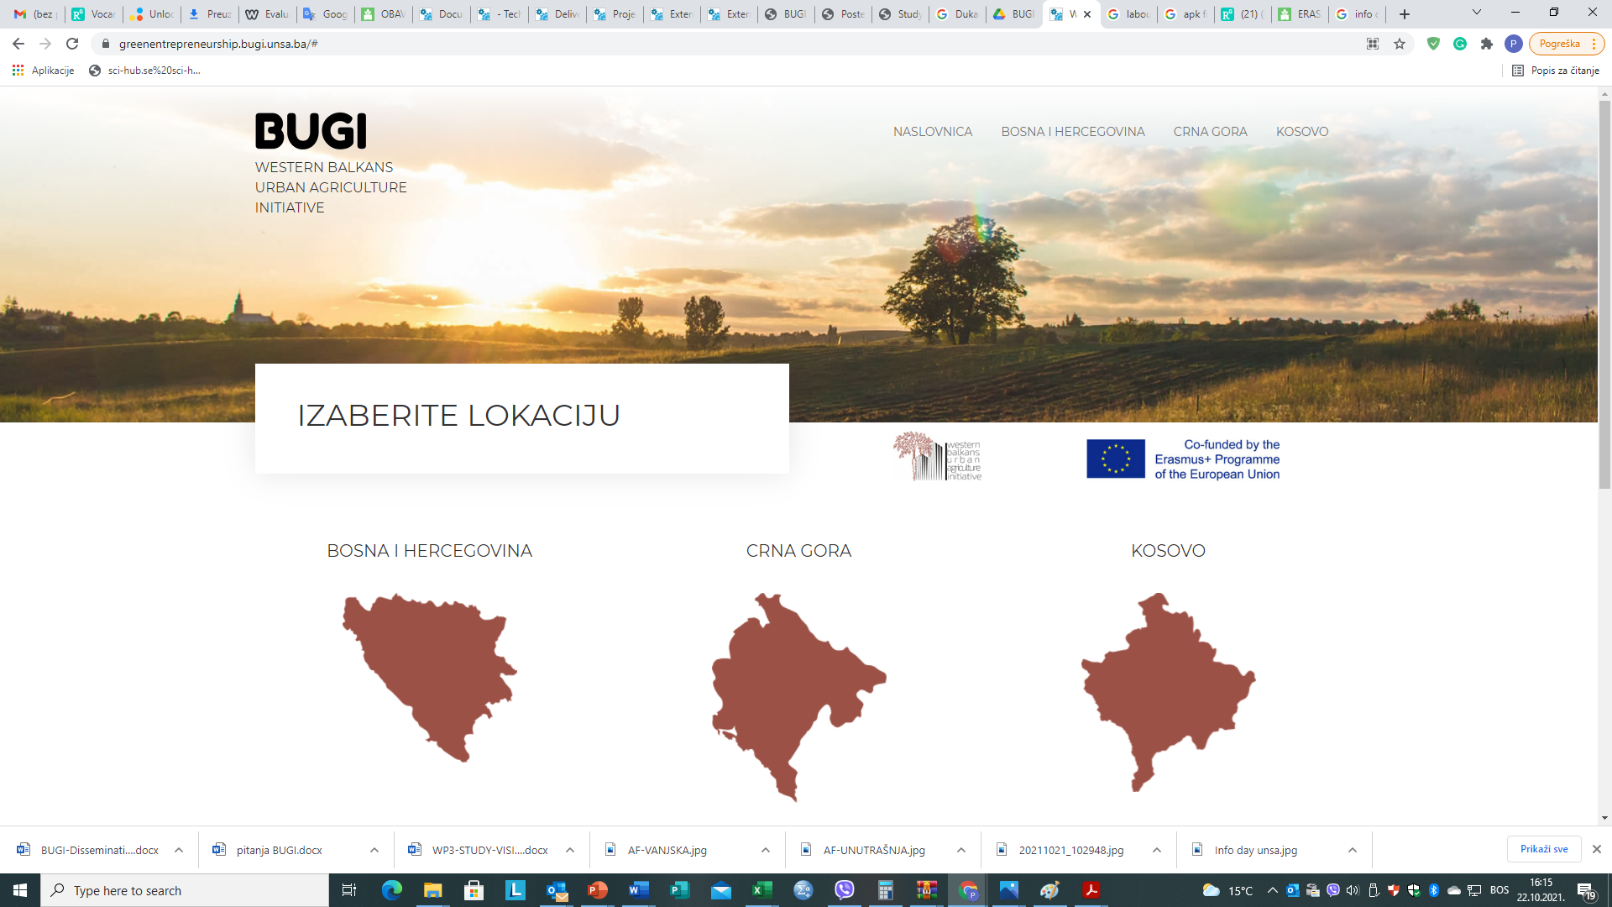

Picture 1. Green Entrepreneurship e-portal

https://play.google.com/store/apps/details?id=com.ismail.bugi

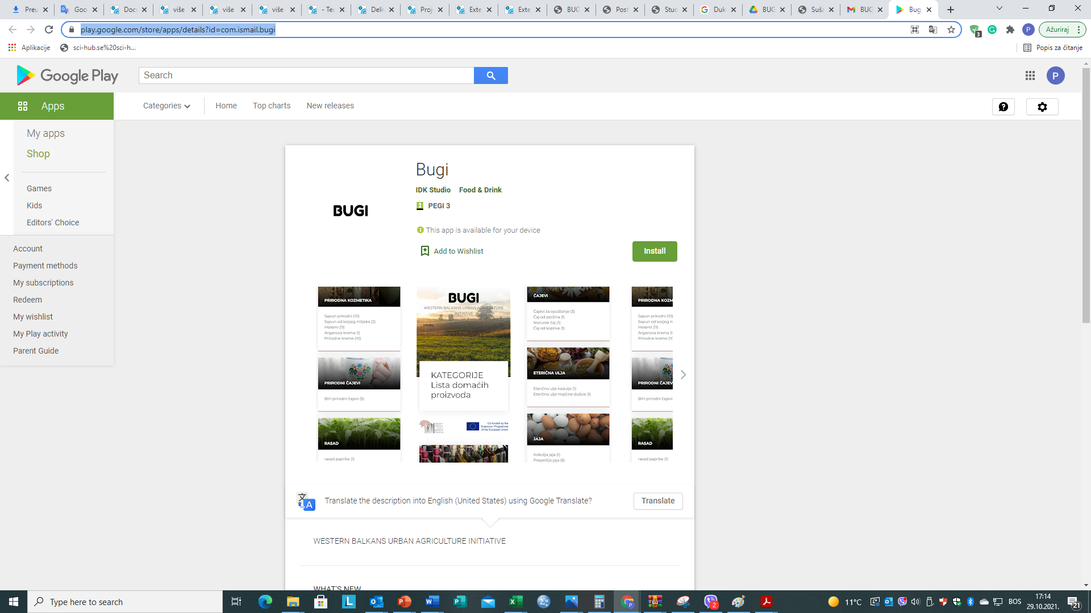
Picture 2. Green Entrepreneurship android application

