Study visit Urban Agriculture in Ruhr Metropolitan Area, Germany
July 18th-20th, 2018
of the Erasmus+ project 586304-EPP-1-2017-BA-EPPKA2-CBHE-JP
Western Balkans Urban Agriculture Initiative – BUGI

Draft Agenda
When | What | Where
July 17th | Arrival
All day | Individual arrivals to Dortmund | From … to Dortmund
 | (further travel instructions see below)
July 18th | “UA business models: Short food supply chains and Alternative Food Networks”
09:00 | Welcome, get to know each other, and general organization (Bernd Pölling) | Zentrum für Gehörlosenkultur, Huckarder Straße 2-8, Dortmund
10:00 | Urban Agriculture in Germany and Ruhr Metropolitan Area (Bernd Pölling)
11:00 | Coffee break
11:15 | City-adjustment strategies and UA business models (Bernd Pölling)
12:30 | Light lunch Vegamaxx // Hofcafé
13:30 | Start of the tour
14:00 | Werkhof: Can social care and business profitability go together? (certified organic horticultural farm; huge tomato varieties; Short chains; social inclusion) (Rita Breker-Kremer) | Werzenkamp 30, Dortmund
16:00 | Community-Supported Agriculture (CSA) Schulte-Tigges: just an alternative illusion or a real business? (Elmar Schulte-Tigges) | Kümper Heide 21, Dortmund
18:00 | Closure and optional joint dinner
July 19th | “Urban Agriculture Curriculum and Aquaponics”
09:00 | Tour to SWUAS, Department of Agriculture, in Soest | Train
10:00 | Overview on SWUAS and Department of Agriculture (Wolf Lorleberg) | Lübecker Ring 2, Soest
10:30 | UA curriculum – lessons learned from the erasmus+ project “Urban Green Train” (Bernd Pölling, Rolf Morgenstern)
12.00 | Introduction Aquaponics (Rolf Morgenstern)
12:30 | Lunch (SWUAS canteen)
13:45 | SWUAS Aquaponic research and demonstration unit (Rolf Morgenstern)
14:45 | Tour to Dortmund | Train
16:00 | Dortmund as an Aquaponic innovation hub? Activities of the NGO “Die Urbanisten e.V.” (NN) | Union Gewerbehof, Huckarder Str. 10-12, Dortmund
18:00 | Closure
July 20th | “Co-production, diversification, and urban planning”
08:30 | Bus tour start
09:15 | “Co-Production”: Urban gardening meets commercial urban farming. The example of a rent-a-field concept and other on-farm diversification (Hubertus Budde) | Bauernhof Am Mechtenberg, Am Mechtenberg 5, Essen
11:00 | Urban planning and regional park “Emscher Landscapes Park” in Ruhr Metropolitan Area (Frank Bothmann, Elisabeth Lux, Regional Association Ruhr) | Haus Ripshorst, Ripshorster Straße, Oberhausen
12:30 | Light lunch (Haus Ripshorst)
14:00 | Tour on on-farm non-agricultural diversification in Ruhr Metropolitan Area (to be defined) | Essen, Castrop-Rauxel
18:00 | Feedback (bus) and closure | Dortmund
July 21st | Departure
All day | Individual departure home | From Dortmund to …

Study visit to Ruhr Metropolitan Area, Germany
July 18th-20th, 2018
of the Erasmus+ project 586304-EPP-1-2017-BA-EPPKA2-CBHE-JP
Western Balkans Urban Agriculture Initiative – BUGI

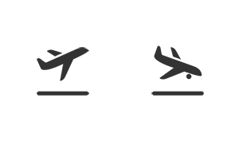
Travel guide

How to come to Dortmund
- Flight
  - For a first overview please see the map of airports in the federal state of North Rhine-Westphalia (Nordrhein-Westfalen), in which Dortmund is centrally located:
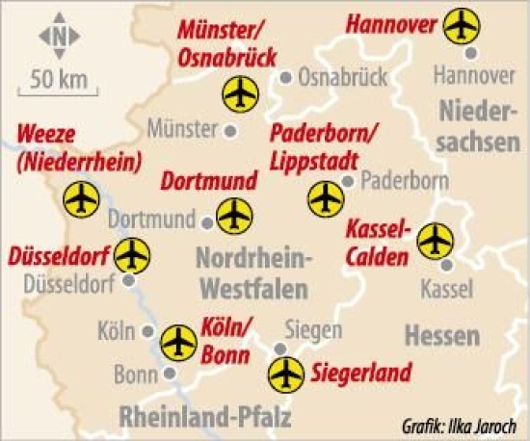

  - We propose to flight either to Dortmund Airport or to Düsseldorf Airport respectively Köln/Bonn Airport; some further information please see below:
  - Dortmund Airport
    - Dortmund's airport is situated at the Southeastern city border of Dortmund. The city centre is easily reachable by local transportation means (bus, local train) or taxi.
    - There might be suitable cheap flights from Western Balkan countries to Dortmund (e.g. Wizzair)
  - Düsseldorf Airport & Köln/Bonn Airport
    - Apart from Dortmund Airport also Düsseldorf Airport (DUS; please pay attention not to make use of the second Düsseldorf airport Weeze NRN) and Köln/Bonn Airport are comfortable flight destinations to reach Dortmund. By train it takes about an hour from Düsseldorf and less than two hours from Köln/Bonn to reach Dortmund.

- Train
  - In case you are interested in travelling by train, you can make use of the website of the German railway company „Deutsche Bahn“ (DB; www.db.de) to look for train connections from your location to Dortmund
  - An option might be a night train to Munich and then further on to Dortmund by e.g. the German high-speed train ICE (e.g. from Ljubljana it takes about 12 hours by train)
- Car
  - Dortmund is very well connected to the German highway system
  - You can easily make use of your navigation system / google maps to plan your car travelling to Dortmund
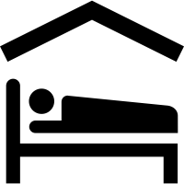
Accommodations
- Just search online
for individual
accommodation,
which suits your personal preferences.
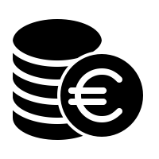
Expected additional costs
related to the study visits

- Local transportation: in total ca. 35 €
  - July 18th: local transportation: ca. 5 €/Person
  - July 19th: Dortmund-Soest-Dortmund: 9 €/Person („Schöner Tag Ticket NRW“ 5 Pers.)
  - July 20th: approx. 20 €/Person
- Lunches: in tital ca. 20 €
  - July 18th: light lunch ca. 8 €
  - July 19th: SWUAS canteen: ca. 6 €
  - July 20th: Haus Ripshorst: ca. 6 €

